National Vocational Certificate level 2-4, in
(Food Processing) “Pine nut / Chillgoza Processor”
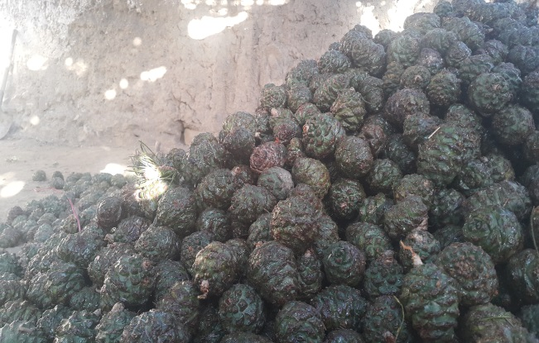
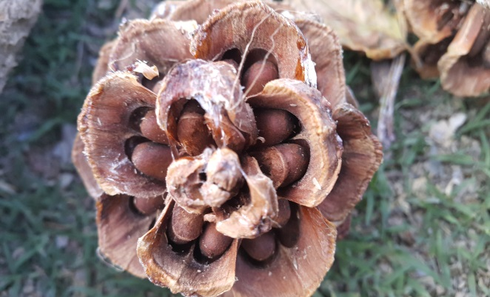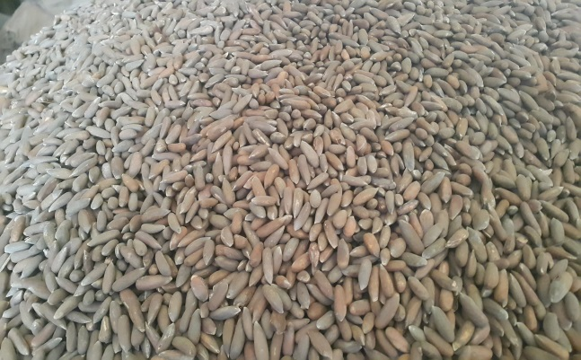
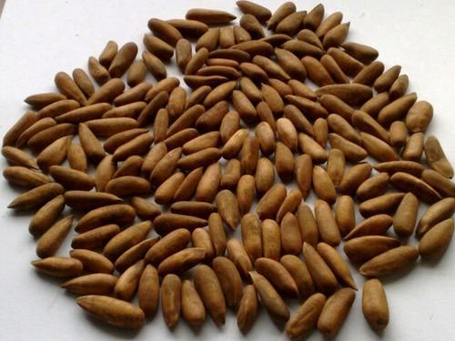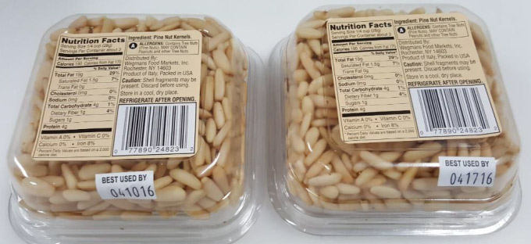
National Vocational and Technical Training Commission (NAVTTC)
Government of Pakistan

TABLE OF CONTENTS

Contents
1. TITLE OF QUALIFICATION 3
2. INTRODUCTION 3
3. PURPOSE OF THE QUALIFICATION 7
4. MAIN OBJECTIVES OF THE QUALIFICATION 8
5. DATE OF VALIDATION 8
6. CODES OF QUALIFICATIONS 8
7. MEMBERS OF QUALIFICATIONS DEVELOPMENT COMMITTEE 9
8. ENTRY REQUIREMENTS 10
9. REGULATIONS FOR THE QUALIFICATION AND SCHEDULE OF UNITS 11
10. SUMMARY OF COMPETENCY STANDARDS 12
Competency Standard A: Collect Pine nut cones from trees 13
Competency Standard B: Extract Pine nuts from cones 16
Competency Standard C: Perform handling & storage at source 20
Competency Standard D: Perform roasting of Pine nuts 23
Competency Standard E: Perform peeling of Pine nuts for Kernel 26
Competency Standard F: Perform Marketing Operations 29
Competency Standard G: Develop Professionalism 32
COMPLETE LIST OF TOOLS AND EQUIPMENT 35

TITLE OF QUALIFICATION

- National Vocational Certificate level 2, in (Food Processing) “Pine nut / Chillgoza Processor”

- National Vocational Certificate level 3, in (Food Processing) “Pine nut / Chillgoza Processor”

- National Vocational Certificate level 4, in (Food Processing) “Pine nut / Chillgoza Processor”

INTRODUCTION

Pakistan’s exports of pine nuts / chillgoza are experiencing an increasing trend and Pakistan is ranked as the second biggest producer of pine nuts just after China. Chillgoza / pine nut is jewel of nuts species. It is found in western Himalayan forests of Pakistan and Afghanistan. Chillgoza pines have similar appearance as stone pines; featuring long slender, pointed kernels. These are famous around the globe for variety, quality taste and colour. Major importers of Pakistani pine nuts were China, US, UK, Scandinavian countries, Middle East and Europe.

The pine nuts are called piñones in Spanish and pinoli or pignoli in Italian. However, the seeds of the pinyon pines (Pinus edulis and Pinus monophylla), which produce in the south-western US and in northern Mexico, are known as pinon nuts. Moreover, several countries of the Far East, Central Asia and Russian Federation also import pine nuts in bulk quantity from Pakistan despite serious challenges of lingual and taxation barriers.

Pine trees grow in the wild cold and taiga forest regions of the northern hemisphere. Interestingly, they are huge, straight erect trees with large stem and may reach up to 75 feet in height with pyramidal or umbrella like dense foliage cover. Even then Pakistani pine nuts remain successful in attracting very good response from the local buyers than pine nuts of other countries on the basis of a peculiar taste and fragrance. Pine nut kernels are, indeed, very good source of plant derived nutrients, essential minerals, vitamins and heart friendly mono-unsaturated fatty acids that help benefit in reducing cholesterol levels in the blood.

Pine nut is an important nut in Pakistani markets as well, and generally it sells around Rs. 2500 to Rs. 3000 per kg. Since Pine nuts grows under special weather conditions and in specific region therefore regards as rear and precious commodity. One of the important reasons of loses among Pine nuts is not availability of any skill training for its harvesting/cutting, roasting and processing. The process of value addition in the same region will also boost its value and provide more benefits to the growers and processors. The locals of Waziristan Agency try to sow its seed but only 3-5 % seeds are successful during cultivation. Moreover, growers do not use appropriate techniques to cut the cones from trees and as a result a lot of damage can be done to the cones of next generation. Similarly wrong methods of extracting pine nuts from cone and while grading and packing of its nuts make it more vulnerable. Lahore is the largest Pine nuts market of Pakistan where as Bannu is the second largest, followed by Peshawar and Karachi markets. Keeping in mind these harms and damages it is mandatory to introduce comprehensive competency based trainings for Pine nut processing.

Pine nuts are famous across the world as one of the best nuts due to its unique taste and nutrition. The increasing demand have not only created a pressure to the growers but also affected the natural process of its cultivation. Under these circumstances it is mandatory to train youth of local community of FATA in general and Waziristan Agency in particular, where 20% forest comprises on Pine nut trees. FATA-Development Authority (FDA) has trained about 1200 in the Pine nuts processors in the training institute in Bannu without any curriculum. The training imparted comprised of one month duration with the support of Market Development Solutions (MDS).

Based on the above desideratum the competency based national vocational qualifications have been developed by NAVTTC to train the unskilled men and women of North and South Waziristan Agencies and FATA on the technical and entrepreneurial skills to be employed / self-employed and inevitably set sustainable impact on their lives by increase in their livelihood income.

Training in the course is based on defined competency standards, which are industry oriented. The traditional role of a trainer changes and shifts towards the facilitation of training. A trainer encourages and assists trainees to learn for themselves. Trainees are likely to work in groups (pairs) and all doing something different. Some are doing practical tasks in the workshop, some writing, some not even in the classroom or workshop but in another part of the building using specialist equipment, working on computers doing research on the Internet or the library. As trainees learn at different pace they might well be at different stages in their learning, thus learning must be tailored to suit individual needs. The following facilitation methods (teaching strategies) are generally employed:

- Direct Instruction Method: This might be effective when introducing a new topic to a larger group of trainees in a relative short amount of time. In most cases this method relies on one-way communication, hence there are limited opportunities to get feedback on the trainee’s understanding.

- Discussion Method: This allows trainees to actively participate in sharing knowledge and ideas. It will help the trainer to determine whether trainees understand the content of the topic. On the other hand, there is a possibility of straying off topic under discussion and some trainees dominating others on their views.

- Small Group Method: Pairing trainees to help and learn from each other often results in faster knowledge/skill transfer than with the whole class. The physical arrangement of the classroom/workshop and individual assessment may be challenging. Analogy method should be in corporate.

- Problem Solving Method: This is a very popular teaching strategy for the training. Trainees are challenged and are usually highly motivated when they gain new knowledge and skills by solving problems (Contingency skills). Trainees develop critical thinking skills and the ability to adapt to new learning situations (Transfer skills). It might be time consuming and because trainees sometimes work individually, they may not learn all the things that they are expected to learn.

- Research Method: This is used for workshops and laboratory tasks, field experiments, and case studies. It encourages trainees to investigate and find answers for themselves and to critically evaluate information. It however requires a lot of time and careful planning of research projects for the trainee.

The detail of the competency standards included in these qualifications are given below:

National Vocational Certificate level 2, in (Food Processing) “Pine nut / Chillgoza Processor”

- Collect Pine nut cones from trees
- Extract Pine nuts from cones
- Perform handling & storage at source

National Vocational Certificate level 3, in (Food Processing) “Pine nut / Chillgoza Processor”

- Collect Pine nut cones from trees
- Extract Pine nuts from cones
- Perform handling & storage at source Perform roasting of Pine nuts
- Perform peeling of Pine nuts Kernel

National Vocational Certificate level 4, in (Food Processing) “Pine nut / Chillgoza Processor”

- Collect Pine nut cones from trees
- Extract Pine nuts from cones
- Perform handling & storage at source Perform roasting of Pine nuts
- Perform peeling of Pine nuts Kernel
- Perform Pine nuts marketing operations
- Develop Professionalism

PURPOSE OF THE QUALIFICATION

The purpose of the training is to provide skilled manpower to improve the existing Pine nut processing industry. This will improve the quality of Pine nuts/Chillgoza in terms of consumer’s acceptability and willingness in local and export markets. The availability of such quality of Pine nuts in the local and international markets will ultimately bring economic benefits to the producers and processors.

MAIN OBJECTIVES OF THE QUALIFICATION

The core objective of these qualifications is to set professional standards for Pine Nuts Processors, who will serve as key elements enhancing quality of Pakistan’s pine nut market. The specific objectives of developing these qualifications are as under:
- Improve the professional competence of pine nut processing
- Capacitate the local community and trainers in modern CBT trainings, methodologies and processes as envisaged under NVQF
- Provide flexible pathways and progressions in Pine nut processing sector
- Enable the trainees to perform their duties in efficient manner
- Establish a standardized and sustainable system of training Pine nut processors in Pakistan

DATE OF VALIDATION

These national vocational qualifications have been validated by the Qualifications Development Committee (QDC) on 2nd and 3rd of November 2017 and will remain in currency until December 2019

CODES OF QUALIFICATIONS

The International Standard Classification of Education (ISCED) is a framework for assembling, compiling and analyzing cross-nationally comparable statistics on education and training. ISCED codes for these qualifications are assigned as follows:

ISCED Classification (Dry nuts Processors)
Code | Description
0721DNP01 | National Vocational Certificate level 2, in (Food Processing) “Pine nut / Chillgoza Processor”
0721DNP02 | National Vocational Certificate level 3, in (Food Processing) “Pine nut / Chillgoza Processor”
0721DNP03 | National Vocational Certificate level 4, in (Food Processing) “Pine nut / Chillgoza Processor”

MEMBERS OF QUALIFICATIONS DEVELOPMENT COMMITTEE

The following members participated in the qualifications development and validation of these qualifications:
Sr. No. | Name | Designation | Organization | Email | Contact No.
1. | Mr. Muhammad Tufail | Project Director | FATA DA, Peshawar | Aco-khyber@fatada.gov.pk | 03459509506
2. | Mr. Imran Khan | Training Coordinator | FATA DA, Peshawar | tcoskills@fatada.gov.pk | 033396116444
3. | Mr. Arshad Farooq | Manager Skills | FATA DA, Peshawar | managerskills@fatada.gov.pk | 03335233490
4. | Mr. Sohail | CBT Section In charge | KP-TTB, Peshawar | Sohail.printing@gmail.com | 03009029806
5. | Mr. Zahid Durrani | Nuts Dealer / Exporter | Hunza Organics, Lahore | hunzaorganics@hotmail.com | 03334349488
6. | Ms. Nighat Ara | Master Trainer / Expert | MDS Malakand | nighat2472@gmail.com | 03449614469
7. | Dr. Qazi Ihsan Mahboob | Professor | Agriculture University, | Qazi148@gmail.com | 03329769601
8. | Mr. Din Muhammad Wazir | Trainer | Wana Welfare Association |  | 03331682400
9. | Mr. Sher Zaman Wazir | Chairman | Forest Deptt. Wana |  | 09652122356  0343-9362581
10. | Mr. Zair Muhammad | Principal | Wana Welfare Association |  | 095211326
11. | Mr. Saeed Sardar | Secretary | KP-TTB, Peshawar | Saeed_srdr@yahoo.com | 03339196510
12. | Mr. Tahir Bashir | M.D | Al Fareed Traders, Peshawar | Tahirbashir75@live.com | 03218584999
13. | Mr. Hakim Khan | Master Trainer | MDS Peshawar | Hakimkhan72@gmail.com | 03005700191
14. | Mr. Saeed Sardar | Secretary | KP-TTB, Peshawar | Saeed_srdr@yahoo.com | 03339196510
15. | Mr. Mushtaq Ahmed | AM Trainings | Punjab TEVTA, HQs Lahore
16 | Syed Salman Shah | Manager Curriculum | P-TEVTA, HQs Lahore
17. | Mr. Khalid Khan | Value Chain Expert | MDS, Peshawar | Khalid.khatki@gmail.com | 03009035100
18. | Ms. Naima Irshad | Instructor GTTI | Punjab TEVTA, Gulberg Lahore
19. | Mr. Tariq Mahmood | Team Leader KPK & FATA | GIZ, Peshawar
20. | Mr. Raja Asad ullah | Technical Advisor | GIZ, Peshawar
21. | Mr. Muhammad Naeem Akhtar | Sr. Technical Advisor | GIZ, Islamabad

ENTRY REQUIREMENTS

The entry qualifications for Pine nuts processor trades are given below:

Title of Qualification | Entry requirements
National Vocational Certificate level 2, in (Food Processing) “Pine nut / Chillgoza Processor” - 0721DNP01 | Entry for assessment / training for this qualification is open. However, entry into formal training institutes, based on this qualification may require skills and knowledge equivalent to primary or literate with some working knowledge of this field.
National Vocational Certificate level 3, in (Food Processing) “Pine nut / Chillgoza Processor” - 0721DNP02 | Entry for this qualification is person having National Vocational Certificate level 2, in (Food Processing) “Pine nut / Chillgoza Processor”.
National Vocational Certificate level 4, in (Food Processing) “Pine nut / Chillgoza Processor” - 0721DNP03 | Entry for this qualification is person having National Vocational Certificate level 3, in (Food Processing) “Pine nut / Chillgoza Processor”. In addition to this the person must have matriculation with fundamental knowledge of marketing of Pine nuts (Demand and supply sides). In addition to this he/she must be computer literate and have knowledge of food standards.

REGULATIONS FOR THE QUALIFICATION

- Pine nut’s Product foods and hazards
- Product health and analysis
- Aflatoxins and its harms
- Food material good storage practices.
- ISO 9001:2008 Including core standards for health.
- Pakistan Standard and Quality Control Authority (PSQCA) Standards.
- Workplace regulations 1992 Ministry of Labour, Govt of Pakistan
- Deal with hazards in accordance with workplace instructions and legal requirements.
- The Management of Health and Safety at Work Regulations 1992 (dermatitis and asthma).
- Environment Protection Agency.
- Basic food and corporate social responsibility standards i.e.

  - Hazard Analysis and Critical Control Point HACCP
  - Global GAP
  - SA-8000

SUMMARY OF COMPETENCY STANDARDS

Code | Competency Standards | Level | Credits | Category
0721DNP01A | Collect Pine nut cones from trees | 2 | 2 | Technical
0721DNP01B | Extract Pine nuts from cones | 2 | 2 | Technical
0721DNP02A | Perform handling & storage at source | 2 | 1 | Technical
0721DNP02B | Perform roasting of Pine nuts | 3 | 3 | Technical
0721DNP02C | Perform peeling of Pine nuts Kernel | 3 | 1 | Technical
0721DNP03A | Perform Pine nuts marketing operations | 4 | 6 | Functional
0721DNP03B | Develop Professionalism | 4 | 5 | Generic
Total |  | 2-3-4 | 20

QUALIFICATION PACKAGESS

These qualifications are assigned and packages as follows:

Code | Description | Competency standards for Packages
0721DNP01 | National Vocational Certificate level 2, in (Food Processing) “Pine nut / Chillgoza Processor” | 0721DNP01A + 0721DNP01B
0721DNP02 | National Vocational Certificate level 3, in (Food Processing) “Pine nut / Chillgoza Processor” | 0721DNP01A + 0721DNP01B + 0721DNP02A + 0721DNP02B + 0721DNP02C
0721DNP03 | National Vocational Certificate level 4, in (Food Processing) “Pine nut / Chillgoza Processor” | 0721DNP01A + 0721DNP01B + 0721DNP02A + 0721DNP02B + 0721DNP02C + 0721DNP03A + 0721DNP03B

Competency Standard A: Collect Pine nut cones from trees

Overview: This competency standard covers the skills and knowledge required to cut Pine cones professionally from trees and sorting of Pine nuts cones according to grades (sizes) and remove the defective cones from the lots.

Competency Units | Performance Criteria
A1: Cut Pine nut cones from trees | Trainee will be able to:  - Select appropriate cutting tools  - Wash hands with soap  - Wear proper Personal Protective Equipment (PPEs) for cutting of Pine nut cones.  - Cut cones from Pine nut trees without damaging the immature cones (Next year)  - Place Pine nut cones at appropriate point.  - Wash hands with soap
A2: Sort Pine nut cones according to grades | Trainee will be able to:  - Segregate Pine nut cones by sizes correctly  - Remove defective Pine nut cones  - Put the cones in bags  - Place Pine nut cones at dry place in a ventilated room / shelter

Knowledge & Understanding

The candidate must be able to demonstrate underpinning knowledge and understanding required to carry out the tasks covered in this competency standard. This includes the knowledge of:

- Harvesting season
- Cones maturity and color
- Proper cutting techniques
- Types and uses of cutting tools
- Identification of Male and Female cones
- Pine nut cones storage techniques
- Difference between healthy and infected cones
- Harms of contamination
- Health and safety

Critical Evidence(s) Required

The candidate needs to produce following critical evidence(s) in order to be competent in this competency standard:

- Cut at least three cones as per standard (Colour, size, maturity) and explain reasons and method of cutting
- Used proper PPEs during cutting of Pine nut cones

Important points

- By cutting some cones from Pine nut trees one can have exact idea about right harvesting season and time.
- Cut the cones from trees with extreme competency and by using the accurate cutting tools
- Collect and store the cones as per standard defined above.
- Wash hands before and soon after cutting with soap
- Use appropriate gloves and goggles etc. while cutting

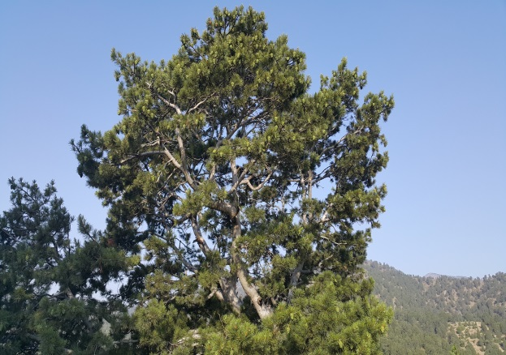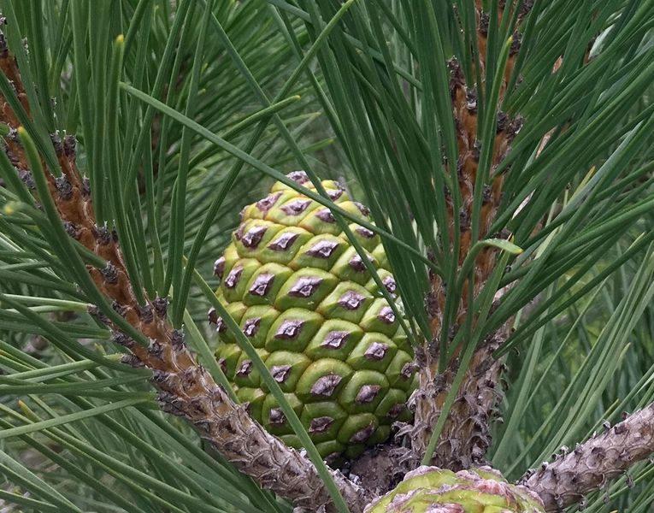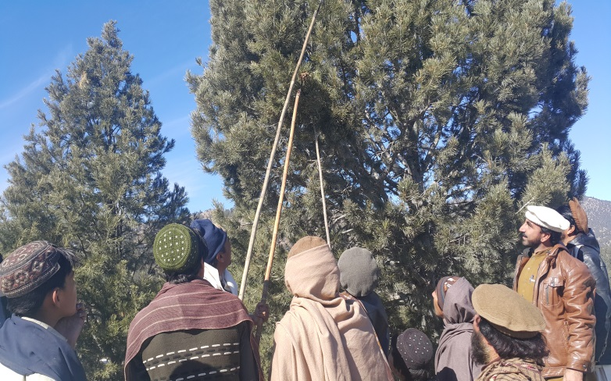
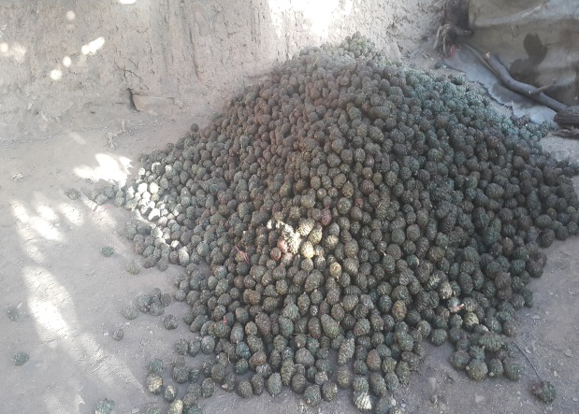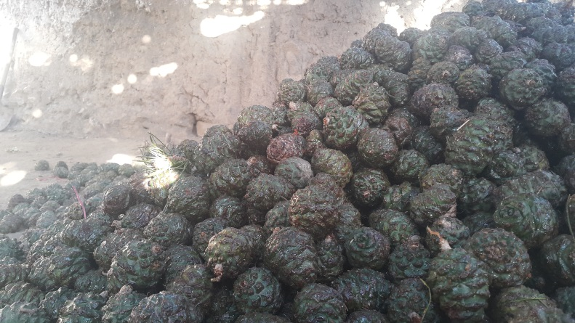

Competency Standard B: Extract Pine nuts from cones

Overview: This competency standard covers the skills and knowledge required to prepare surface for placement of pine nut cones after cutting, dry pine nut cones for extraction of Pine nuts, all kinds of Pine nuts extraction techniques and how to reduce excessive moisture and remove foreign material from the extracted Pine nuts by using adequate personal protective equipment.

Competency Units | Performance Criteria
B1. Prepare surface for placement of Pine nut cones | Trainee will be able to:  P1. Identify the appropriate place for drying  P2. Smooth the surface with mud plaster (Lippai)  P3. Dry the surface for placement of cones
B2. Dry Pine nut cones for extraction | Trainee will be able to:  P1. Select proper heating/Drying method  P2. Heat the Pine cones for extraction of Pine nuts as per SOP
B3. Separate Pine nuts from cones | Trainee will be able to:  P1. Extract Pine nuts from opened cones  P2. Spread semi opened cones at perforated surface  P3. Beat cones with wooden stick to extract the Pine nuts  P4. Extract rest of the Pine nuts with the help of wooden pointer / wooden hammer from semi opened cones, one by one correctly
B4. Reduce excessive moisture from Pine nuts | Trainee will be able to:  P1. Spread Pine nuts in open air in thin layers to reduce excessive moisture  P2. Shuffle the Pine nuts on regular intervals for uniformity
B5. Remove Foreign Material from Pine nuts | Trainee will be able to:  P1. Remove foreign material from Pine nuts with fan / blower (air treatment)  P2. Remove foreign material from Pine nuts with the help of sieves  P3. Manually remove foreign material from Pine nuts  P4. Grade the Pine nuts according to their size and colour
B6. Adopt health and safety measures during extraction | Trainee will be able to:  P1. Wash hands properly with soap  P2. Wear PPEs as per requirements

Knowledge & Understanding

The candidate must be able to demonstrate underpinning knowledge and understanding required to carry out the tasks covered in this competency standard. This includes the knowledge of:

- Extraction methods, techniques and related Standard Operating Procedure (SOP)
- Drying techniques of Pine nuts
- Harms of infected pine nuts and their preventive measures during extraction
- Types and uses of Pine nuts extraction tools including mechanical extraction machinery
- Health and safety guidelines for extraction (Gloves, Goggles, Masks, Socks)

Critical Evidence(s) Required

The candidate needs to produce following critical evidence(s) in order to be competent in this competency standard:

- Extracted Pine nuts from cones with all three methods by:
  - Hands
  - Beating with wooden stick
  - Wooden pointer / hammer

- Graded 2 Kg Pine nuts by removing foreign materials as per:
  - Size (A,B and C categories)
  - Colour (White, Brown and Black)

Important points

- Pine nuts cones normally open naturally in 6-8 days under the sun
- Use wooden hammer of small size for extracting some of the semi opened cones
- Extracted Pine nuts must be placed on a clean cloth sheet
- Extracted Pine nuts must be stored in boxes
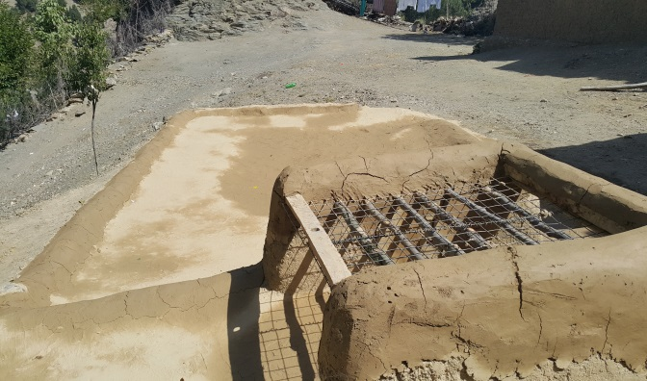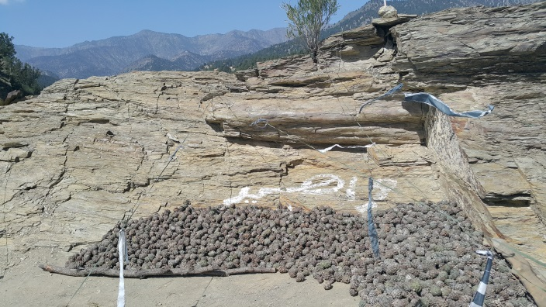
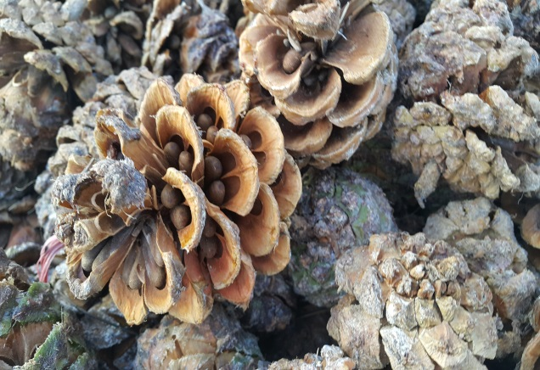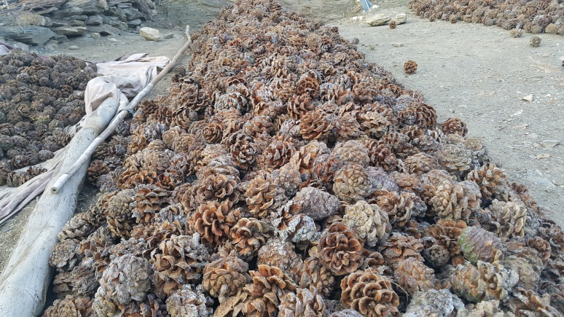
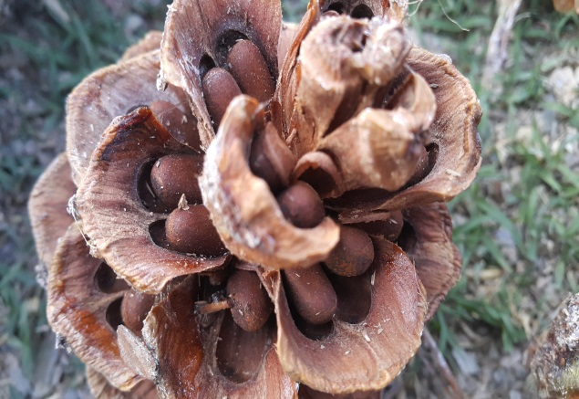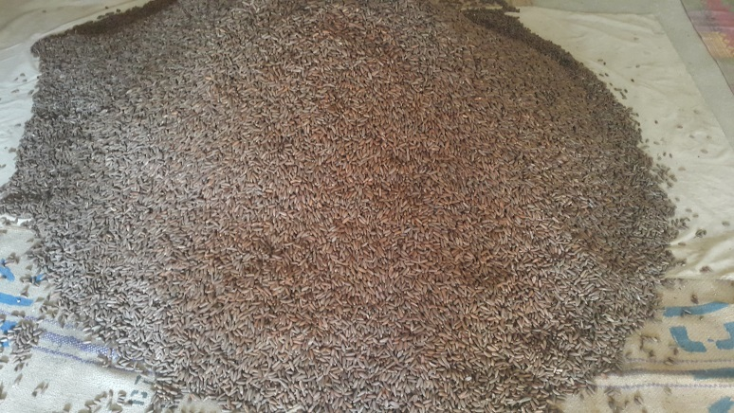

Competency Standard C: Perform handling & storage at source

Overview: This competency standard covers the skills and knowledge required to sort Pine nuts as per grading requirements (sizes and colours), pack Pine nuts as per instructions and properly transport the packed Pine nuts.

Competency Units | Performance Criteria
C1. Sort Pine nuts as per grading | Trainee will be able to:  P1. Sort Pine nuts according to size (A,B and C category)  P2. Sort Pine nuts according to colour (White, Brown and Black)  P3. Remove infected Pine nuts from the lot
C2. Pack Pine nuts as per requirements | Trainee will be able to:  P1. Select packing material according to instructions  P2. Fill the Pine nuts in the packing material
C3. Transport Pine nuts to the desired destination | Trainee will be able to:  P1. Select suitable transport means  P2. Load the Pine nuts on selected transport as per instructions  P3. Despatch Pine nuts to the desired market

Knowledge & Understanding

The candidate must be able to demonstrate underpinning knowledge and understanding required to carry out the tasks covered in this competency standard. This includes the knowledge of:

- Types of Pine nuts packaging material
- Importance of packaging material for Pine nuts
- Moisture levels in Pine nuts
- Customers’ requirements for packing of Pine nuts

Critical Evidence(s) Required

The candidate needs to produce following critical evidence(s) in order to be competent in this competency standard:

- Graded 2 Kg Pine nuts by removing foreign materials as per:

  - Size (A,B and C categories)
  - Colour (White, Brown and Black)

- Packed 2 Kg Pine nuts as per instructions and explain the importance of packing materials and mark for traceability

Important points

- Pine nuts are dried in 2-3 days at 24-29 degree centigrade
- Clean the surface soon after grading

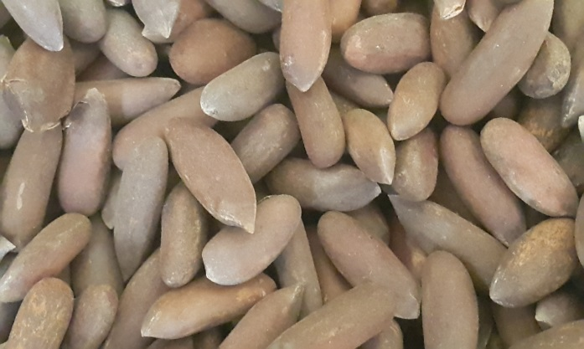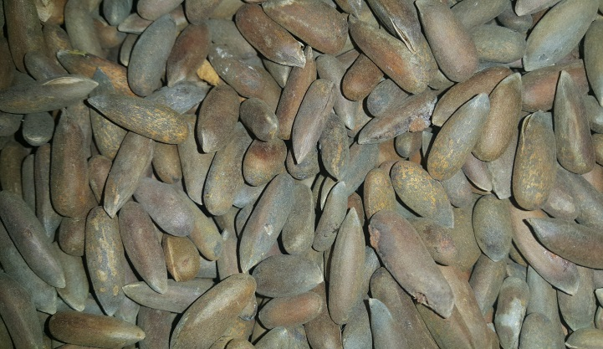

Competency Standard D: Perform roasting of Pine nuts

Overview: This competency standard covers the skills and knowledge required to roast Pine nuts as per requirements, remove infected Pine nuts after roasting and pack roasted Pine nuts, as per instructions and properly transport the packed Pine nuts to the desired destination.

Competency Units | Performance Criteria
D1: Roast Pine nuts as per requirements | Trainee will be able to:  P1. Select roasting equipment as per instructions  P2. Roast the Pine nuts as per requirement  P3. Clean roasting equipment after use  P4. Place/Store roasting equipment at designated point
D2: Remove infected Pine nuts | Trainee will be able to:  P1. Remove infected Pine nuts with fan / Air blower as per SOP  P2. Remove infected Pine nuts with the help of sieves  P3. Manually remove infected Pine nuts
D3: Pack roasted Pine nuts as per requirement | Trainee will be able to:  P1. Select packing material as per requirement  P2. Weigh-out the roasted Pine nuts for packing  P3. Pack the Pine nuts according to requirements
D4: Transport roasted Pine nuts to the desired destination | Trainee will be able to:  P1. Select suitable transport means  P2. Load the Pine nuts on selected transport as per instructions  P3. Despatch Pine nuts to desired market

Knowledge & Understanding

The candidate must be able to demonstrate underpinning knowledge and understanding required to carry out the tasks covered in this competency standard. This includes the knowledge of:

- Types and uses of Pine nuts roasting equipment
- Pine nuts roasting methods and techniques

Critical Evidence(s) Required

The candidate needs to produce following critical evidence(s) in order to be competent in this competency standard:

- Performed roasting of 2 Kg Pine nuts as per instructions
- Packed 2 Kg roasted Pine nuts according to guideline

Important points

- Roast the pine nuts after proper natural drying
- Hard shell pine nuts be roasted for 20-30 minutes at 50 to 75 degree centigrade
- Soft shell pine nuts be roasted for 10-20 minutes at 50 to 60 degree centigrade
- Continuously shake the pine nuts while roasting
- Use proper gloves while roasting and grading
- Place pine nuts at clean and cool place after roasting
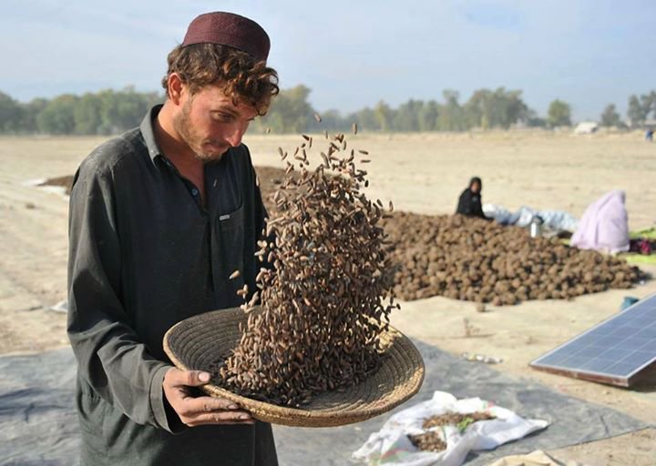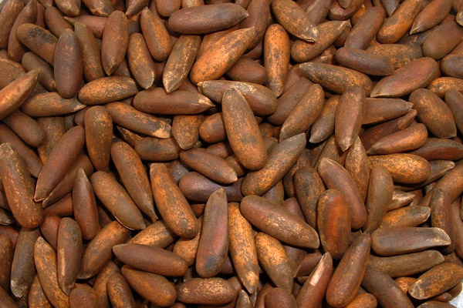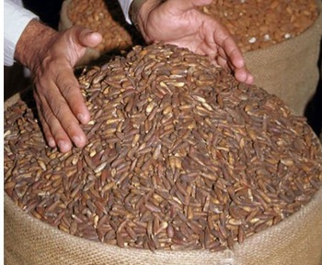

Competency Standard E: Perform peeling of Pine nuts for Kernel

Overview: This competency standard covers the skills and knowledge required to select appropriate Pine nuts for Kernels, roast the Pine nuts and after peeling of kernels, soaking and peeling of Pine nuts, drying and removing membrane from kernels and finally perform packing of kernels.

Competency Units | Performance Criteria
E1: Roast Pine nuts for Kernel | Trainee will be able to:  - Select Pine nuts for roasting for kernels  - Select roasting equipment for Pine nuts  - Roast the Pine nuts, as per requirement  - Clean the roasting equipment  - Store the roasting equipment at designated point
E2: Perform peeling of Pine nuts for Kernels extractions | Trainee will be able to:  - Soak roasted Pine nuts in warm water as per requirements  - Remove shells (Peeling) of soaked Pine nuts correctly  - Spread peeled Kernels on appropriate surface as per requirements to reduce moisture
E3: Dry Kernels for removing membrane | Trainee will be able to:  - Spread the Kernels for drying to remove Kernel membrane  - Remove Kernel membrane by rubbing gently with a neat cloth  - Remove Kernel membrane by the help of blower
E4: Sort Kernels as per requirements | Trainee will be able to:  - Sort Kernels with the help of sieves for grading  - Separate the unhealthy Kernels manually
E5: Perform Packing of Kernels | Trainee will be able to:  - Select the packing material as per requirement  - Pack the Kernels as per instructions

Knowledge & Understanding

The candidate must be able to demonstrate underpinning knowledge and understanding required to carry out the tasks covered in this competency standard. This includes the knowledge of:

- Pine nuts roasting techniques for Kernel
- Peeling techniques
- Types and uses of personal protective equipment

Critical Evidence(s) Required

The candidate needs to produce following critical evidence(s) in order to be competent in this competency standard:

- Performed roasting of 1 Kg Pine nuts for Kernels, as per instructions
- Performed peeling of 50 Pine nuts

Important points

- Peeling must be performed by hands after properly washing by hands
- For attaining quality put the kernels in boxes for appropriate time
- Clean the surface before and after peeling
- Remove the thin membrane from kernels with clean cloth after soaking
- Use the most suitable fresh and attractive packing material

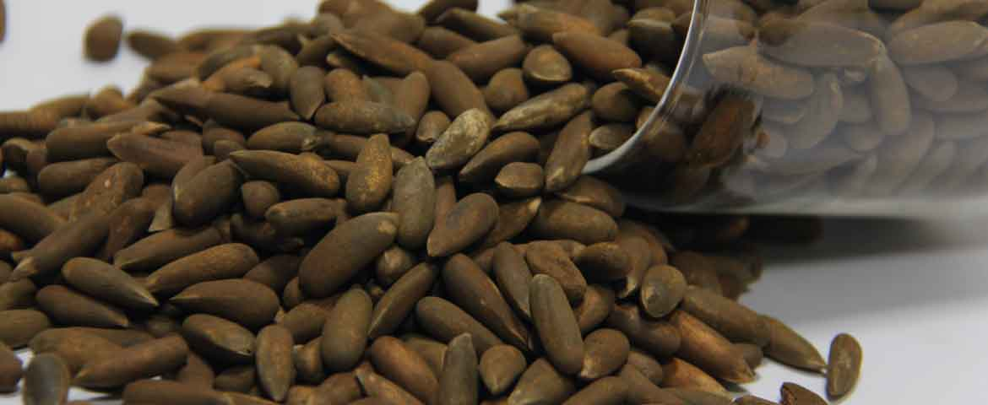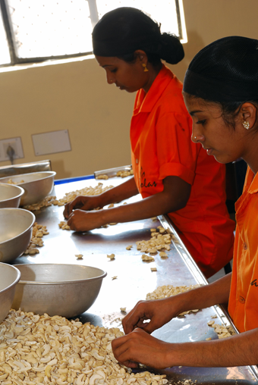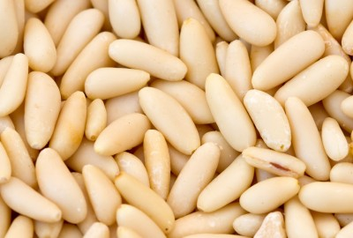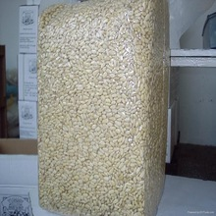

Competency Standard F: Perform basic Marketing Operations

Overview: This competency standard covers the skills and knowledge required to analyse Pine nut market trends (both demand and supply sides), prepare most feasible and beneficial market plan and execute that plan.

Competency Units | Performance Criteria
F1: Analyse Pine nuts market trends | Trainee will be able to:  - Identify market demands for Pine nuts  - Study Pine nuts supply side of the market  - Make a contacts list of Traders / Agents / Brokers of the Pine nuts market
F2: Prepare Marketing Plan for sale of Pine nuts | Trainee will be able to:  - Plan product supply as per various markets requirements  - Set price(s) according to various market requirements  - Select target market(s)  - Select promotional means, according to target market(s)
F3: Execute Marketing Plan | Trainee will be able to:  - Pack Pine nuts (grade wise) as per requirement  - Finalize the business deal  - Apply label (mark) on the packed bags  - Adopt correct means of transportation  - Despatch finished product to the market

Knowledge & Understanding

The candidate must be able to demonstrate underpinning knowledge and understanding required to carry out the tasks covered in this competency standard. This includes the knowledge of:

- Basic concepts of marketing
- Trends of markets (Demand and supply etc.)
- Knowledge of 4Ps

  - Product
  - Price
  - Promotion
  - Placement

- Pine nut’s Product knowledge
- Product health and analysis
- Basic Food standards i.e. HACCP, Global GAP, SA-8000 etc.

Critical Evidence(s) Required

The candidate needs to produce following critical evidence(s) in order to be competent in this competency standard:

- Performed role playing properly as Buyer and Seller and they will negotiate to finalize a realistic business deal

Important points

- Packed material must be kept on wooden racks 6-9 inches higher then ground surface
- Use proper amount of Aluminium Phosphate to protect food from insects
- Collective marketing strategy should be adopted in collaboration with Pine nuts marketing association
- There must be proper negotiation among buyers and sellers
- If the cost will be reduced the profit will be higher
- If we grade all production simultaneously it will reduce the cost tremendously
- Products from the same region must be reached collectively to the processors dealers and whole sellers
- The right combination of all 4Ps of the market must be used

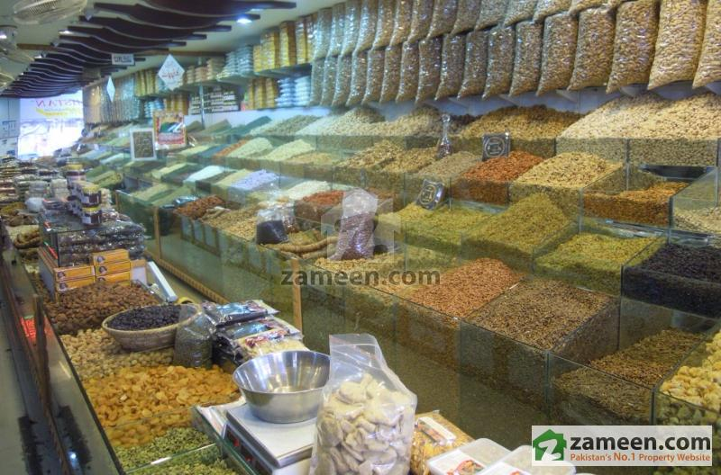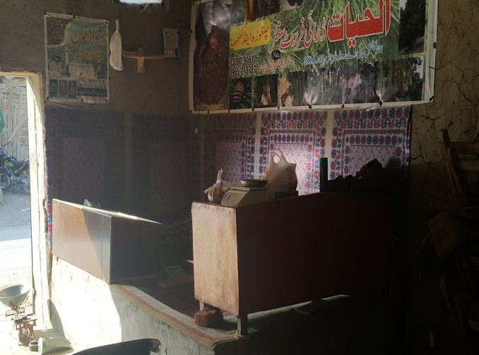

Competency Standard G: Develop Professionalism

Overview: This competency standard covers the skills and knowledge required to develop professional attitude and follow environmental health and safety rules strictly.

Competency Units | Performance Criteria
G1. Develop professional attitude. | Trainee will be able to:  - Analyse upcoming market trends.  - Develop Professional network.  - Demonstrate behavioural skills.  - Develop sound interpersonal skills  - Develop communication skills.
G2. Follow Environmental, Health and Safety Rules. | Trainee will be able to:  - Follow Health and Safety Rules  - Ensure Personal Safety  - Ensure Machine Safety  - Ensure Work Place Safety  - Ensure safety while operating irons.  - Store all flammables in a safe area.

Knowledge & Understanding

The candidate must be able to demonstrate underpinning knowledge and understanding required to carry out the tasks covered in this competency standard. This includes the knowledge of:

- Professionalism (meaning, attitude, output, timely delivery, networking)
- Behavioral skills.
- Importance of trends and market research.
- Interpersonal skills
- Communication skills
- Market norms
- Significance of personal hygiene
- Types of Hazards in the Workplace
- Various Parts of Machine while troubleshooting.
- Handling of Sewing Machines.
- Significance of workplace cleanliness.
- Handling of Electric Supply and Appliances
- Organizational Health and Safety Rules
- Process to handle emergency situations.
- Types of materials which can catch fire.

Critical Evidence(s) Required

The candidate needs to produce following critical evidence(s) in order to be competent in this competency standard:

- Make a list of material which can catch fire
- Explain the importance of health and safety
- Brief about types of hazards at workplace

Important points

- Must be conscious about health and safety measures at work place
- Can communicate professionally with outsiders and within organisation

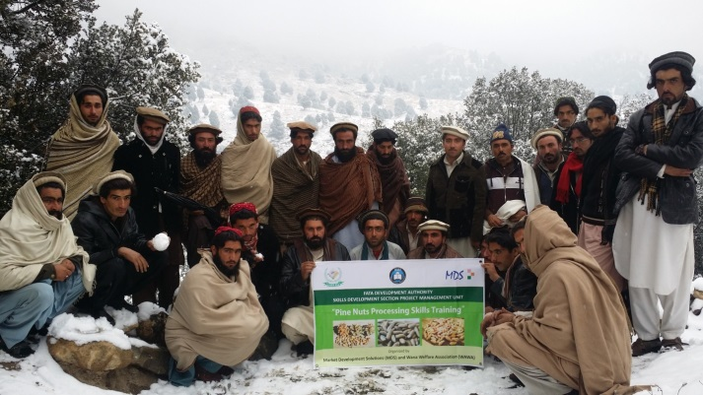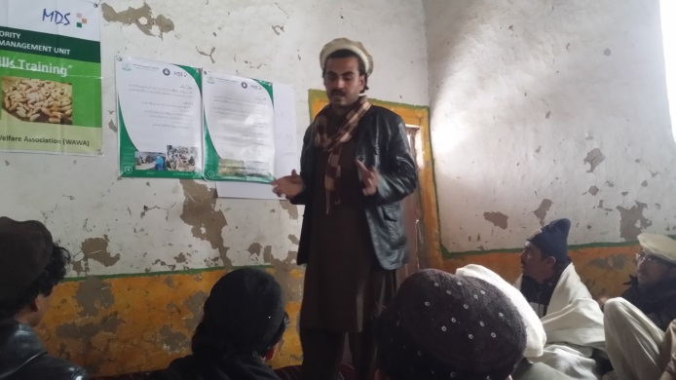

COMPLETE LIST OF TOOLS AND EQUIPMENT

Sr. # | Description | Quantity
 | Pine nuts cone cutters with baskets | 5
 | Gloves | 25 pairs
 | Wooden hammer for extraction | 5
 | Wooden Pointer for extraction | 5
 | Heating Pit | 2
 | Air blower | 2
 | Generator | 1
 | Pallets | 3
 | Jute / Cotton bags (Air ventilation) | 5
 | White Board | 1
 | Multimedia | 1
 | Dry roaster (Proto type) | 1
 | Moisture meter | 5
 | Stitching bag machine | 2
 | Pedal sealers | 1
 | Sieves (3 different sizes) | 5 each
 | Computer | 1
 | Printer | 1
 | Goggles | 25
 | Ladder | 5
 | Safety harness for tree climbing | 5
 | First Aid Box | 1
 | Aprons | 25
 | Weighing scale (up-to 5 kg) | 1
 | Weighing scale (up-to 100 kg) | 1

